# **PSFA Mobile Flashover Simulator**

# 8 hour course

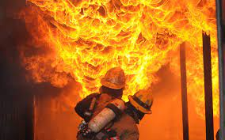**Course Description:**

This 1-day course is designed to give the student the skills and knowledge that are required to recognize and understand the flashover stage of an interior compartment fire. The primary focus of this course is to give the student a thorough knowledge of flashover and pre-flashover conditions.

**Course Objectives:**

The goal of this course is to teach the student how to deal with these conditions in a safe and productive manner.  
The ultimate outcome is to equip fire fighters with the skills to avoid becoming victims of this violent phenomenon. Live fire evolutions conclude this course

**Course Pre-Requisites:**

|  |
| --- |
|  |

Successful completion of a program that includes live fire such as Structure 1, Structural Burn Session (SBS), Interior Firefighter w/ live fire, or Firefighter 1 certification.

**Course Dates:**

***June 21, 2025 or June 22, 2025***

The course is provided by ***Northampton County Emergency Management & Northampton County Fire School*** at no cost.

***Lunch will be provided both days.***

**Location On Line Registration**

Northampton County Fire School <HTTPS://psfa.acadisonline.com>

6 Nagys Hill Rd. Contact Michael A Rampulla at

Bangor, PA 18013 mrampulla@ncem-pa.org

or 610-746-3194 x3229 with any

questions